CODE: CSA0238

NAME: LOSHINI.L

REG NO: 192571015

Basic Input/Output and Operators (2/8/25)

**1.Write a C program to add two integers**

**IPO**

* Input: get two values as input say a and b
* Process: add the two inputs using the formula c=a+b
* Output: the output is to print the sum of two integers

**Program**

#include <stdio.h>

void main()

{

int a,b,c;

printf("Enter value of a : ");

scanf("%d", &a);

printf("Enter value of b: ");

scanf("%d", &b);

c=a+b;

printf("c= %d\n",c);

}

**output**

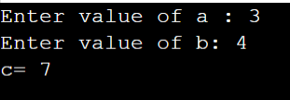

**2. Write a program to swap two numbers using a temporary variable.**

**IPO**

* Input: Get two values as input, say a and b.
* Process**:** Swap the values of a and b using a temporary variable with the logic:  
  c = a; a = b; b = c;
* Output**:** The output is to print the values of a and b after swapping.

**Program**

#include <stdio.h>

void main()

{

int a,b,c;

printf("Enter value of a : ");

scanf("%d", &a);

printf("Enter value of b: ");

scanf("%d", &b);

c=a;

a=b;

b=c;

printf("a=%d\nb=%d\n",a,b);

}

**output**

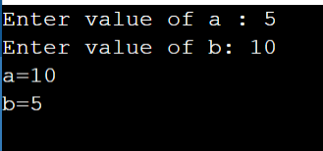

**3. Write a program to swap two numbers without using a temporary variable.**

**IPO**

* Input**:** Get two values as input, say a and b.
* Process**:** Swap the values of a and b without using a third variable ,  
  a = a + b;  
  b = a - b;  
  a = a - b;
* Output**:** The output is to print the values of a and b after swapping.

**Program**

#include <stdio.h>

void main()

{

int a,b;

printf("Enter value of a : ");

scanf("%d", &a);

printf("Enter value of b: ");

scanf("%d", &b);

a=a+b;

b=a-b;

a=a-b;

printf("a=%d\nb=%d\n",a,b);

}

**output**

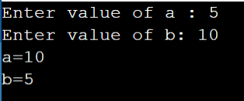

**4. Write a program to find the ASCII value of a character**

**IPO**

* Input: Get a character as input say ch.
* Process: Find the number (ASCII value) for that character.
* Output**:** The output is to print the ASCII the entered character.

**Program**

#include<stdio.h>

void main()

{

char ch;

printf(“enter a character: “);

scanf(" %c", &ch);

printf("The ASCII value of '%c' is %d\n", ch, ch);

}

**output**

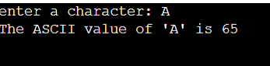

**5. Write a program to calculate the area and perimeter of a rectangle.**

**IPO**

* Input:  
  Get two values as input length and breadth of the rectangle.
* Process:
* Calculate the area using the formula: area = length * breadth
* Calculate the perimeter using the formula: perimeter = 2 * (length + breadth)
* Output:  
  The output is to print the area and perimeter of the rectangle.

**Program**

#include<stdio.h>

void main()

{

float area,perimeter,length,breadth;

printf("Enter length of the rectangle: ");

scanf("%f",&length);

printf("Enter breadth of the rectangle: ");

scanf("%f",&breadth);

area=length*breadth;

perimeter=2*(length+breadth);

printf("Area=%.2f\n",area);

printf("Perimeter=%.2f\n",perimeter);

}

**output**

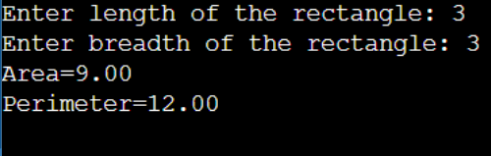

6. Write a program to compute the simple interest.

**IPO**

* Input:  
  Get three values as input say p,r,t
* Process:  
  Calculate the simple interest using the formula:  
  simple interest = (p *r * t) / 100
* Output:  
  The output is to print the calculated simple interest.

**Program**

#include<stdio.h>

void main()

{

float p,r,t,a;

printf("enter value of p:");

scanf("%f",&p);

printf("enter value of r:");

scanf("%f",&r);

printf("enter value of t:");

scanf("%f",&t);

a=(p*r*t)/100;

printf("simple interest is %.2f",a);

}

**output**

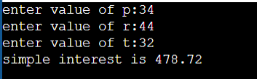

7. Write a program to convert temperature from Celsius to Fahrenheit.

**IPO**

* Input:  
  Get one value as input say c
* Process:  
  Convert Celsius to Fahrenheit using the formula:  
  fahrenheit = (celsius * 9 / 5) + 32
* Output:  
  The output is to print the temperature in Fahrenheit.

**Program**

#include<stdio.h>

void main()

{

float c,f;

printf("enter celsius:");

scanf("%f",&c);

f=(c*9/5)+32;

printf("The temperature in fahrenheit is %.2f",f);

}

**output**

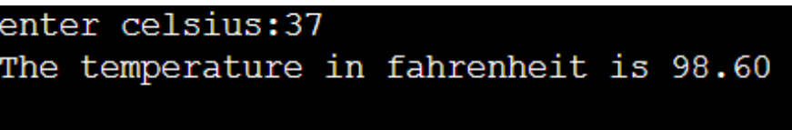

**8. Write a program to find the quotient and remainder of two integers.**

**IPO**

* Input:  
  Get two values as input num1 and num2.
* Process:

Calculate the quotient using: quotient = num1/num2

Calculate the remainder using: remainder = num1%num2

* Output:  
  The output is to print the quotient and remainder of the given the given numbers .

**Program**

#include<stdio.h>

void main()

{

int num1,num2,quotient,reminder;

printf("enter a number1 :");

scanf("%d",&num1);

printf("enter a number2 :");

scanf("%d",&num2);

quotient=num1/num2;

reminder=num1%num2;

printf("quotient=%d\n",quotient);

printf("reminder=%d\n",reminder);

}

**output**

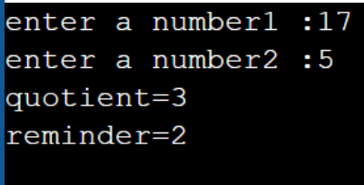

9. Write a program to check whether a number is even or odd.

**IPO**

* Input:  
  Get one integer as input say num.
* Process:  
  Check the remainder when the number is divided by 2 using the condition:

If num % 2 == 0, it's even

Otherwise, it's odd

* Output:  
  The output is to print whether the number is Even or Odd.

**Program**

#include<stdio.h>

void main()

{

int num;

printf("enter a number:");

scanf("%d",&num);

if(num%2==0)

printf("even");

else

printf("odd");

}

**output**

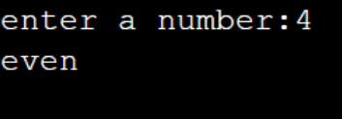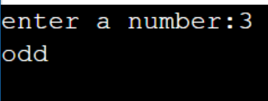

**10. Write a program to calculate the square and cube of a number.**

**IPO**

* Input:  
  Get one number as input , say num.
* Process:

Calculate the square using the formula: square = num * num

Calculate the cube using the formula: cube = num * num * num

* Output:  
  The output is to print the square and cube of the given number

**Program**

#include<stdio.h>

void main()

{

int num,square,cube;

printf("enter a number :");

scanf("%d",&num);

square=num*num;

cube=num*num*num;

printf("square=%d\n",square);

printf("cube=%d\n",cube);

}

**output**

